R. Reports Menu: 3. Election Participation Report

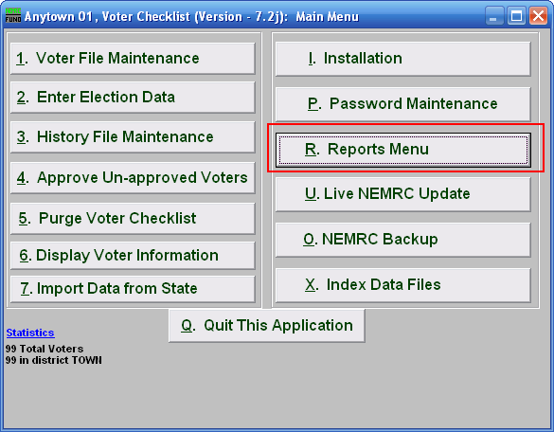
Click on “R. Reports Menu” from the Main Menu and the following window will appear:

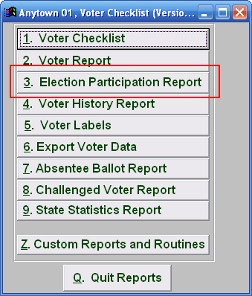
Click on “3. Election Participation Report” from the Reports Menu and the following window will appear:

Election Participation Report

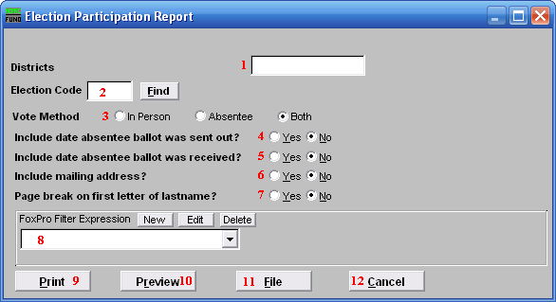
- Districts: Enter the district code or codes to include in this report.

- Election Code: Enter the election code for the election that this report will be on, or click “Find” and select from there.

- Vote Method: Enter the method of participation that this report will be on.

- Include date absentee ballot was sent out?: Select whether or not the date that the absentee ballot was sent out is included on the report. Only effective if you chose “Absentee” or “Both” for item 3.

- Include date absentee ballot was received?: Select whether or not the date that the absentee ballot was received back is included on the report. Only effective if you chose “Absentee or “Both” for item 3.

- Include mailing address?: Select whether or not each voter’s mailing address is included on the report.

- Page break on first letter of lastname?: Select “Yes” to start a new page for every new first letter of each last name.

- FoxPro Filter Expression: A conditional reporting expression developed with NEMRC support. This evaluates account information to determine if the account should be included. Contact NEMRC support to learn more about this option.

- Print: Click this button to print. Refer to GENERAL PRINTING for more information.

- Preview: Click this button to preview. Refer to GENERAL PREVIEW for more information.

- File: Click this button to save on this computer. Refer to GENERAL FILE for more information.

- Cancel: Click “Cancel” to cancel and return to the Reports Menu.

